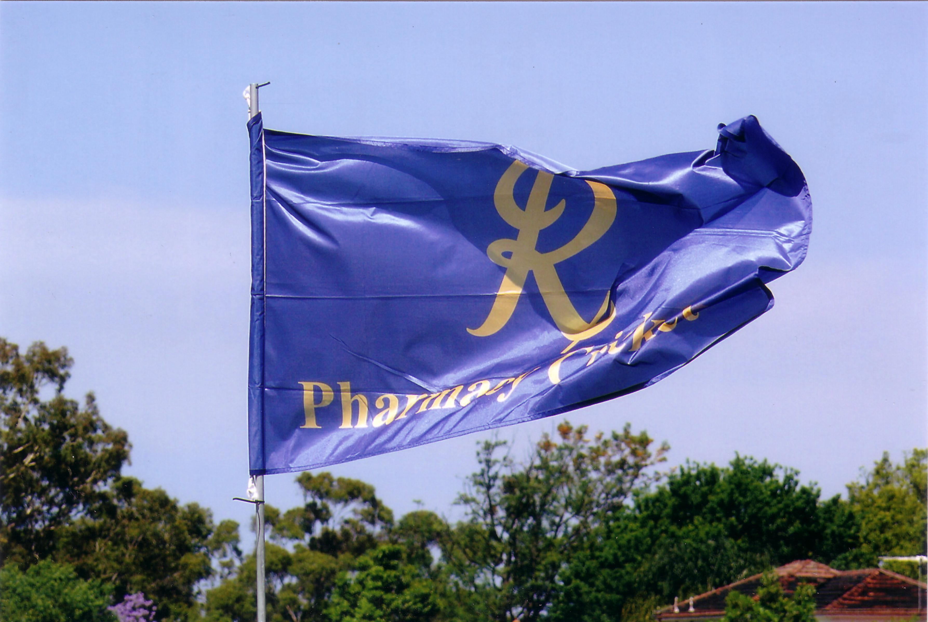
Pharmacy Cricket
Industry has its revenge

Having been dismissed last season in February 2009 for 88, the Industry team under the captaincy of Ben Sullivan (Apotex) scored 6 for 244 in their 50 overs at the main ground of Shore School at Northbridge on Sunday February 21st. Top scorers were Adrian McCaffrey 54 retired (Key Pharmaceuticals) and Jason Blanchard 45 not out (API). The pharmacy team with an extra player available, lent Nathan Blackmore to the Industry team. Nathan opening the innings scored 48 and had an opening partnership with Peter Frazer (Guild Lawyers) of 68.
Of the 10 pharmacy bowlers tried, Danny Huynh had the best figurers of 2 for 27 off his 5 overs. Although not taking a wicket Sylvester Sein off his 7 overs conceded only 19 runs.
The Pharmacy team in reply lost their first wicket in the second over 1 for 6. Over number nine saw Tim Sallway (bowling like Bollinger and named ‘Man of the Match) in his 4th over take a hat trick, 3 wickets with consecutive balls, to finish his 7 overs with 3 for 15.
Pharmacy continuing to loose wickets to be 6 for 41, then 9 for 93. Captain Steve Thompson 36 and Chris Georges 38 not out came together and played aggressively for the last wicket taking the score to 141 before Thompson was dismissed. Two of the Pharmacy team had duck for dinner.

To be able to play cricket on a cloudless rather warm day with gentle winds on the immaculate A ground of Shore School and to sit in the wonderful new pavilion was a privilege and a pleasure that I am sure all present including the various family groups thoroughly enjoyed.
After a great day of cricket the trophy presentation and the match award were followed by fellowship and story telling that all enjoyed.

